Rock Crawling!

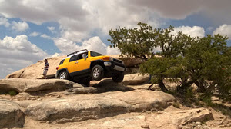
Rock crawling is an extreme form of off road driving using vehicles anywhere from stock to highly modified to overcome obstacles. In rock crawling, drivers drive highly modified four-wheel-drive vehicles such as trucks, Jeeps, and "buggies" over very harsh terrain. Driving locations include boulders, mountain foothills, rock piles, mountain trails, etc.
Rock climbing is about slow-speed, careful and precise driving, and high torque generated through large gear reductions in the vehicles drivetrain. Rock crawlers often drive up, down and across obstacles that would appear impassable. Such vehicles to rock climb are primarily 4x4s.
Rock crawling competitions range from local events to national series. A rock crawling competition consists of obstacle courses that are about 100-200 yards long. Each obstacle is set up with gates, similar to a ski course.

The Vehicles
Vehicles are outfitted with custom parts. Power is usually not an issue, as rock crawlers typically lower their gear ratios in order to drive more slowly over obstacles without stalling the engine.

Vehicles Commonly Used
- Jeep and varients
- Lada Niva
- BAW
- Nissan Patrol
- Toyota Hilux
- Toyota Land Cruiser
- Land Rover
- Mercedes-Benz G-Class
- Santana PS10
- Ford Bronco
- Suzuki Samurai
- Mercedes Unimog

Custom parts can include:
- Locking differentials
- Taller off-road tires
- Upgraded suspension
- Four wheel steering
- Roll cage
- Engine increased torque
- Lowered gearing
- Winches
- Body armor
- Portal axles

Mountain Area Locations
There are several locations dedicated to Rock climbing and other off-road activities but in this article we will discuss only the ones located in the mountain area.

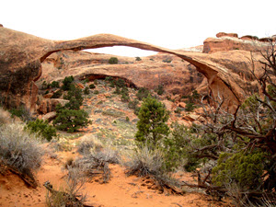
Moab, Utah
Moab is a city in Grand County, in eastern Utah, in the western United States. The population was 5,046 at the 2010 census. It is the county seat and largest city in Grand County. Moab attracts a large number of tourists every year, mostly visitors to the nearby Arches and Canyonlands National Parks. The town is a popular base for mountain bikers who ride the extensive network of trails including Slickrock Trail, and off-roaders who come for the annual Moab Jeep Safari.

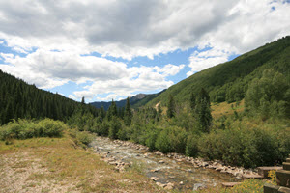
Cortez, Colorado
The City of Cortez is a Home Rule Municipality that is the county seat and the most populous municipality of Montezuma County, Colorado, United States. The city population was 8,482 at the 2010 United States Census.

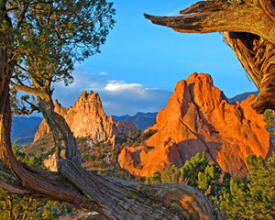
Colorado Springs, Colorado
Colorado Springs is a home rule municipality that is the county seat and the most populous municipality of El Paso County, Colorado, United States. Colorado Springs is located in the east central portion of the state. It is situated on Fountain Creek and is located 60 miles (97 km) south of the Colorado State Capitol in Denver.

Mountain Locations Price
Locations Price
AreaBFE, Moab, UT Free
Battle Rock Off Road Park, Cortez CO Unkown
Ram Off Road Park, Colorado Springs, CO Starting at $10 (Depending on equipment)

